**VAIBHAVI PATIL ROLL.NO23**

**LDA QDA**

library(MASS)

library(caret)

library(ROCR)

**## Loading Data & Preprocessing**

df = read.csv("breast-cancer.csv")

dim(df)

df = df[,2:32]

str(df)

colSums(is.na(df))

df$diagnosis = as.factor(df$diagnosis)

str(df)

**## Checking for Outlier**

b=boxplot(df)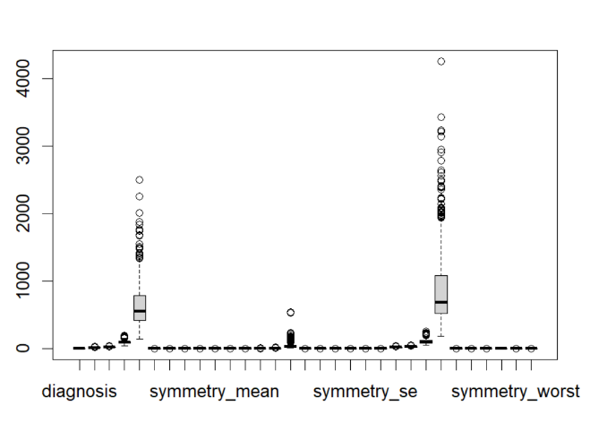

**## Making LDA Model**

actual_lda = lda(diagnosis ~ . , data=df)

**## Predicting**

predicted_lda = predict(actual_lda)

**## Plotting Prediction**

plot(predicted_lda$x, col = as.numeric(predicted_lda$class), pch = 19,

xlab = "LD1", ylab = "LD2", main = "Scatter Plot of LDA")

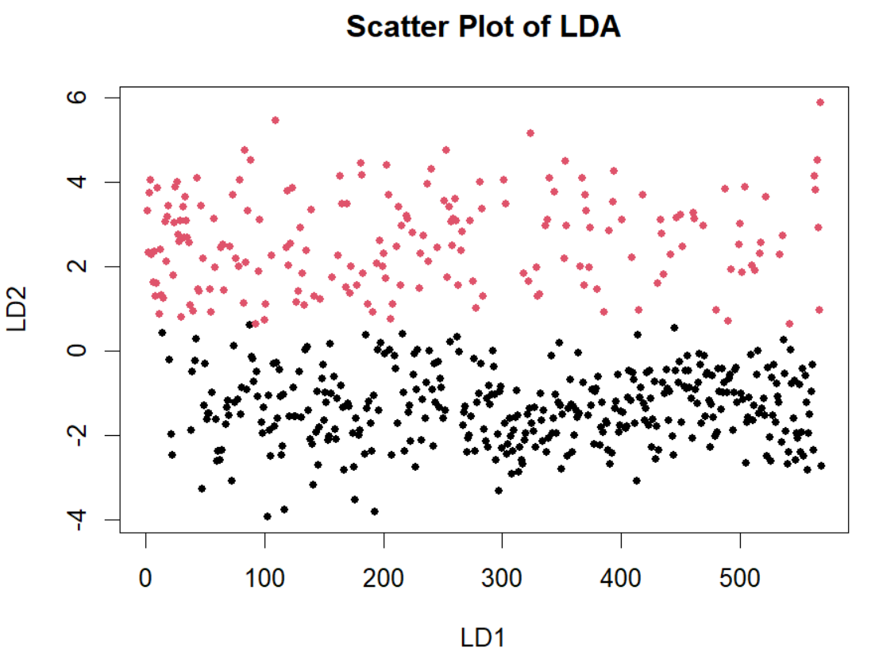

**## Confusion Matrix**

confusionMatrix(predicted_lda$class,df$diagnosis)$table

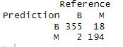

**## Accuracy**

mean(predicted_lda$class==df$diagnosis)



**## Finding Prediction True Positive vs False Positive**

pred_lda <- prediction(predicted_lda$posterior[, "M"], df$diagnosis == "M")

perf_lda <- performance(pred_lda, "tpr", "fpr")

**## Ploting ROC Curve for LDA**

plot(perf_lda, col = "blue", lwd = 2, main = "ROC Curve", xlim = c(0, 1), ylim = c(0, 1), xlab = "False Positive Rate", ylab = "True Positive Rate")

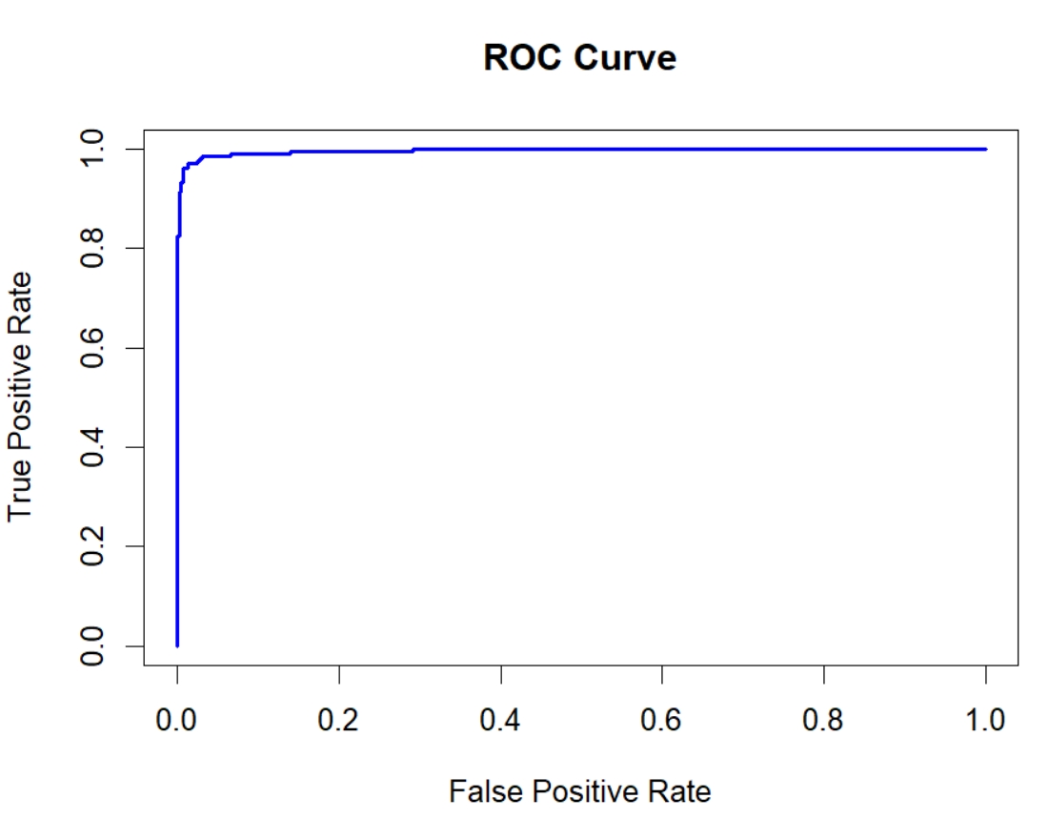

**## AUC Score**

auc_lda <- performance(pred_lda, "auc")

print(paste("AUC for LDA:", [auc_lda@y.values[[1]])](mailto:auc_lda@y.values[[1]])))



**## QDA Model**

actual_qda = qda(diagnosis ~ . , data=df)

**## Prediction using Model**

predicted_qda = predict(actual_qda)

**## Accuracy**

mean(predicted_qda$class==df$diagnosis)



**## Confution Matrix**

confusionMatrix(predicted_qda$class,df$diagnosis)$table

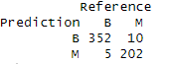

**## Finding Prediction True Positive vs False Positive**

pred_qda <- prediction(predicted_qda$posterior[, "M"], df$diagnosis == "M")

**# Create performance object for ROC curve**

perf_qda <- performance(pred_qda, "tpr", "fpr")

**# Plot ROC curve**

plot(perf_qda, col = "red", lwd = 2, add = TRUE)

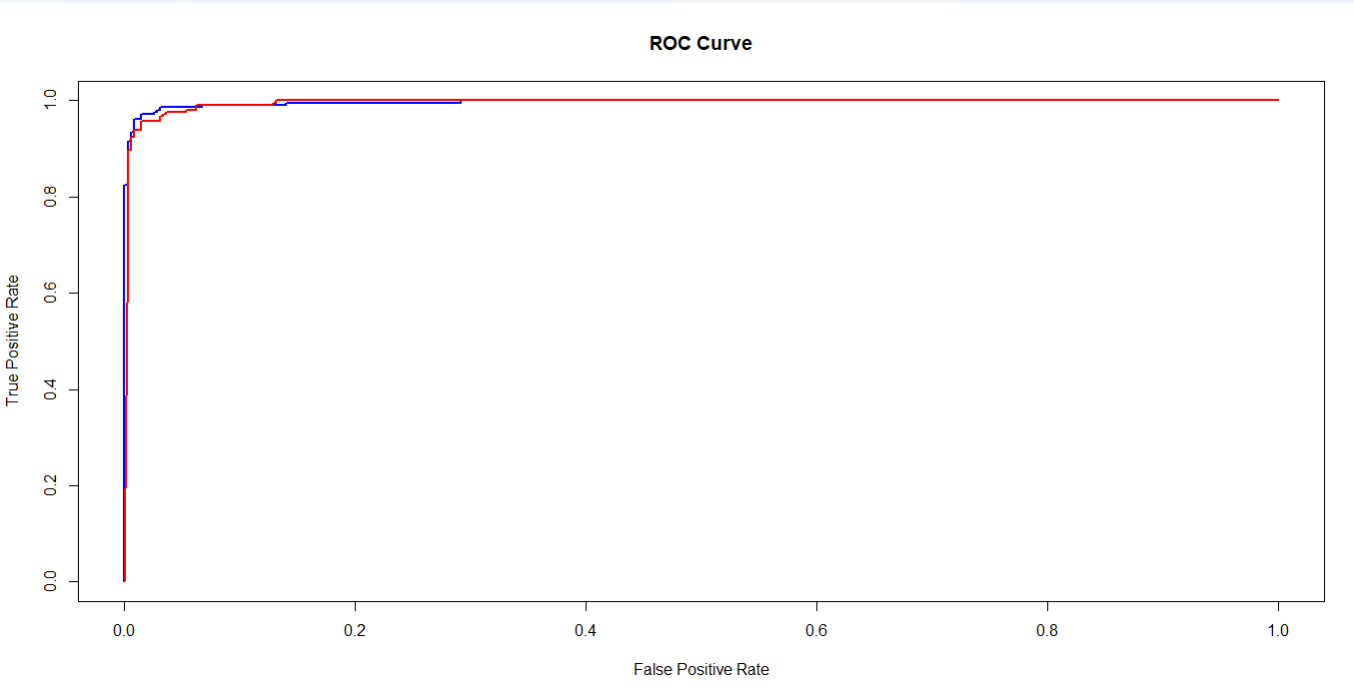

**# Calculate AUC**

auc_qda <- performance(pred_qda, "auc")

print(paste("AUC for QDA:", [auc_qda@y.values[[1]])](mailto:auc_qda@y.values[[1]])))



**Interpretation:**

1. **Based on Confusion Matrix LDA accuracy was slightly lower than QDA.**
2. **Based on ROC Curve & AUC Score, LDA was 0.996 and QDA was 0.995**
3. **Finally, we can conclude that LDA (20 misclassified) has predicted more misclassified points compared to QDA (15 misclassified)**